HOTELDEALS.COM

**TEAM-16 MEMBERS**

**Saxena, Amitendra - A20391066 -** [asaxena13@hawk.iit.edu](mailto:asaxena13@hawk.iit.edu)

**Aleem, Alisha Anjum -A20379905 -** [aanjum1@hawk.iit.edu](mailto:aanjum1@hawk.iit.edu)

**Kanura, Uday - A20388396 –** [ukanuri@hawk.iit.edu](mailto:ukanuri@hawk.iit.edu)

**Dasari, Narayana - A20376520 –** [ldasari@hawk.iit.edu](mailto:ldasari@hawk.iit.edu)

*CSP584-Enterprise Web Application*

*Dr. Atef Bader*

*12/02/2017*

Contents

Final Design System Documentation **Error! Bookmark not defined.**

1.0 Introduction………………………………………………………………………………….. 3

1.1 Goals and objectives 3

1.2 Statement of scope 3

1.3 Software context 4

1.4 Requirements 4

1.4.1 Functional Requirements 4

1.4.2 Non-functional requirements 7

1.4.3 Environmental requirements 7

2.0 User Scenario………………………………………………………………………………...8

2.1 User profiles: 8

Customers 8

Admin 8

Hotel manager 8

2.2 Use-cases 8

3.0 Data Model and Description……………………………………………………………….13

3.1 Data objects 13

4.0 Class Diagram………………………………………………………………………………15

5.0 Outputs………………………………………………………………………………………16

6.0 Conclusion…………………………………………………………………………………..30

# Requirement Specification Documentation

1. **Introduction**

We provide our customers with their favorite hotel reservations at various locations made easier than ever. With every query, HotelDeals.com searches to show customers the information they need to find the right hotels and vacation packages.

## 1.1 Goals and objectives

The main goal of this website is to make an online Hotel Reservation anywhere across the world in ease. The objective of this project is to create an online enterprise web application which we named as ‘HotelDeals.com’. The intent is to build an application that will allow customer to book rooms from the application through online. The store will have mainly three significant roles which are Customer, Admin and hotel manager. Users can check the availability of rooms and facilities. Hotel managers will be able to serve the walk-in customers and maintain the rooms and will know the details of reservations and reviews.

## 1.2 Statement of scope

The tool is mainly used for booking a Hotel Room of Customer’s choice. Hotels can be searched by various choices like entering the location, by check-in and check-out dates or by entering the zipcode. The essential goal is to search for hotels in accurate location and avail good deals. The Scope of the Project is to provide an interface to the customers that can interact with the system on a web based application which provides a list of hotels in their preferred location and selected dates etc. The List of features is presented below.

The application shall be accessible through a web browser such as chrome, Firefox, Safari and so on. It shall prompt the customer for a username and password when they want to finalize their reservation. If not signed up, it will directly take them to the new user sign up page. Upon entering this information correctly, the user shall have access to the booking of their preferred hotel, hotel type and also good deals. For the users, they shall be able to sign up, sign in, personal account,make a booking, cancel the booking, submit review and rating . In additional, the users shall able to select rooms based on features like Pricing, Rating, zip code.. The users shall do this by the interactive features in the main page of the website.

## 1.3 Software context

The software is used to register courses efficiently. It is a web based application which basically consists of MVC architecture. Application server (JSP, Servlets, AJAX) will mainly handle the web application. The application will communicate to the database (MongoDB) to communicate and retrieve information. Users shall use a browser (Firefox, Chrome, Safari) to access the application after starting Apache Tomcat Server. Hotels searched by Zipcode is implemented using Google API and the search for hotels in search bar has an autocomplete feature using AJAX

## 1.4 Requirements

The functional, non-functional and environmental requirements are listed below:

### 1.4.1 Functional Requirements

1. The system shall check the validity of Username and password for existing users.

Input: User specifies username and password and clicks on ‘submit’.

Processing: The system refers to its backend database to check if the username - password combination is valid.

Output: If credentials are invalid, display error and return to login screen

1. The system shall enable customer to make reservation for a Hotel Room. A list of Hotels is displayed for the customer to choose based on their choice of location, zipcode, check-in and check-out dates or ratings and reviews of the hotel.

Input: Customer enters location ‘City’, selects check-in and check-out dates, Number of Guests and clicks on the ‘Search’ button

Processing: The system does the following validation checks:

If there are number of Hotels in the Location?

If any availability of the hotel rooms in the preferred dates?

Output: If any of the above is true, display appropriate list’ of hotels for the customers to go ahead with the booking.

1. The system shall enable customer to look up for Hotel rooms in specified zipcode. The list of hotels will show up.

Input: customer chooses to lookup the hotels in a particular zipcode. No other inputs.

Processing: Fetch the list of hotels for this user from the backend database

Output: Display the list of Hotels

1. The system shall enable customer to cancel the hotel room they reserved. A list of reserved hotels is displayed for the customer to choose and cancel if more than one booking is made in their bookings page.

Input: customer chooses a hotel room from the list and clicks on ‘cancel’.

Processing: The system checks removes the hotel room reservation from the list of ‘reserved hotel’ for the customer and updates the backend database .

Output: If Cancellation was successful, display a message indicating Cancellation Succesful to user and show the updated list of Hotels from the main page. Else, display the reason for error.

1. The system shall enable customer to edit profile. Information for Email address, phone number, password and name can be changed.

Input: customer chooses to edit his profile information. User enters the details that he wishes to change (Email address, phone number and password are the updatable fields)

Processing: The system checks if the new password (if set) conforms to the password guidelines. If not, display an alert to user. Else, proceed further. System checks if the phone number entered is a valid one (country code followed by the number of digits needed for a phone number in that country). If not valid, display an alert to user. Else, proceed with updating the database with new details.

Output: If update was successful, display a message indicating success to user and show the updated profile. Else, display the reason for error.

1. The system shall enable admin to add or delete Hotel.

Input: admin chooses to add new hotels or delete hotels. No other input expected.

Processing: The system gets the list of information required to add Hotel to the page saving it to the backend database while clicking on ‘Remove’ button leads to deleting a hotel from the page as well as the backend Database

Output: Display a message that Added or Deleted succcesfully.

1. The system shall enable the admin to add or delete Hotel Manager

Input: admin chooses to add new hotel managers or remove them. No other input expected.

Processing: The system gets the list of information required to add Hotel Manager to the page saving it to the backend database while clicking on ‘Remove’ button leads to deleting a hotel manager from the page as well as the backend Database

Output: Display a message that Added or Deleted succcesfully.

1. The system shall enable the Hotel Manager to view all the bookings of hotels which are done by the customer and Hotel Manager can cancel any bookings based on the requirements.

### 1.4.2 Non-functional requirements

1. Security: The system should protect privacy. The system should allow only customers to view/edit his/her personal information.
2. Availability: The system should be available and running at least 99% of time. 3. Scalability: The system should be able to serve up to three thousand users concurrently.
3. Ease of use: The system should be user friendly and intuitive. The user should not take more than 2 minutes to get through a certain activity (registering / dropping a course) and not more than 3 minutes to while creating a new account.
4. The system should provide facility to get Reviews and Ratings from customers. Customers are requested to rate on a scale of 5 on their Experience of stay, and free text comments can be entered as review.

### 1.4.3 Environmental requirements

1. Customer, Hotel Manager and Admin needs a web browser (Firefox, Safari, chrome etc.) to connect to the

system.

1. Customer, Hotel Manager and Admin must be connected to the internet, and should have internet access speeds of at least 64kbps.

**2.0 User Scenario:**

## 2.1 User profiles:

## Customers

Users of the system are Customers. Customers can sign up, sign in, view their profile, search hotels, make a reservation, cancel reservation, Review and Rate them

## Admin

Admin can sign in, Add/ Delete a Hotel or Hotel Manager. Admin has access to the Data Analysis Page to make better business decisions on to target potential customers.

## Hotel manager

Hotel Manager can sign in, Add/ Delete Hotel, View booking and edit the Hotel Details and prices

## 2.2 Use-cases

All use-cases for the software are presented.

2.2.1 Use case of the customer

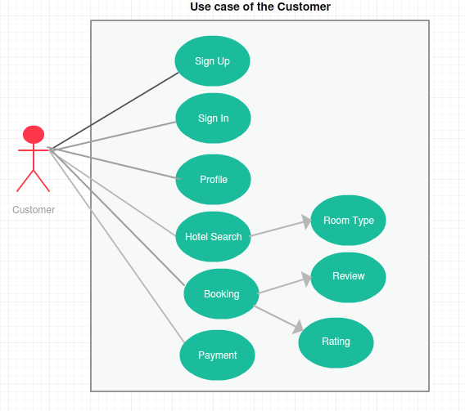

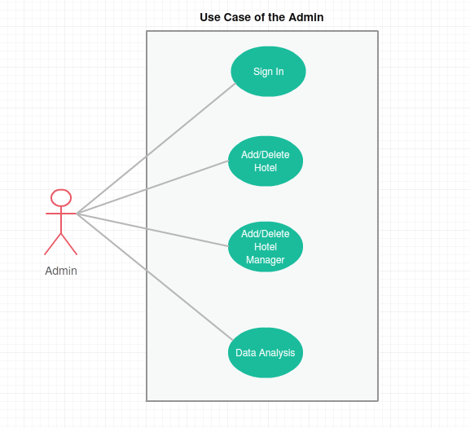

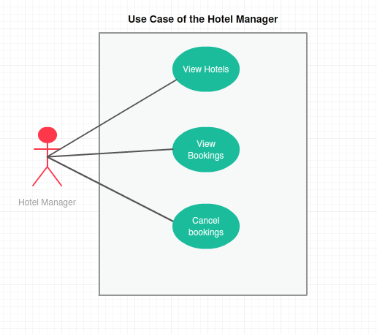

**Domain Dictionary:**

|  |  |  |
| --- | --- | --- |
| **Name** | **Type** | **Description** |
| User | Role | - Create/edit account OR shop as a guest user.  - Search hotel room/s  - Rate/review hotel room/s  -Place reservations/cancel reservation/s  - See reservations history |
| Hotel Admin | Role | - Can add/delete/update hotel rooms.  - Can view at the data analytics reports.  - Manage product discounts |
| Reservation/s | Object | - List of rooms which customer likes to have |
| Reviews | Object | - List of reviews from customers |
| Add/Update/Delete hotel rooms | Process | - Admin can add/update/delete hotel rooms |
| Placing/Canceling reservations | Process | - Method of placing reservation online or canceling it if not interested and Hotel manger can also cancel any booking. |
| Payment of reservation | Process | - Method of paying for the reservation through credit card |
| Search of hotel rooms | Process | - Method of searching hotel rooms |
| Data Analytics Report | Function | - It is the functionality of generating the report for data analytics |

**2.3 Special usage considerations:**

This system is built basing on web. So a standard web browser is very important and necessary, such as Google chrome, Microsoft edge and Firefox.

**3.0 Data Model and Description**

This section mainly describes the information domain for this registration web application.

## 3.1 Data objects

Following are the data objects in our database without relationship.

|  |  |  |  |  |
| --- | --- | --- | --- | --- |
| **Schema Name** | **Attribute** | **Type** | **Constraint** | **Note** |
| **ACCOUNTHOLD**  **ER (Customer, Admin, Hotel Manager)** | UserName | VARCHAR(20  ) | Primary Key | Account |
| Password | VARCHAR(15  ) | NOT NULL |  |

|  |  |  |  |  |
| --- | --- | --- | --- | --- |
| **CUSTOMER** | E-mail ID | VARCHAR(20) | Primary Key |  |
| Age | INT(9) | NOT NULL |  |
| Customer Name | VARCHAR(25) | NOT NULL | Composition, separate into LName and FName |
| Address | String(20) | NOT NULL |  |
| Phone | INT(20) | NOT NULL |  |
|  | Occupation | VARCHAR(25) | NOT NULL |  |
| Gender | VARCHAR(10) | NOT NULL | Select from the options |
| Password | VARCHAR(20) | NOT NULL |  |
|  | Retype Password | VARCHAR(20) | NOT NULL |  |

1. **Class Diagram:**



1. **Output:**
   1. Home Page:

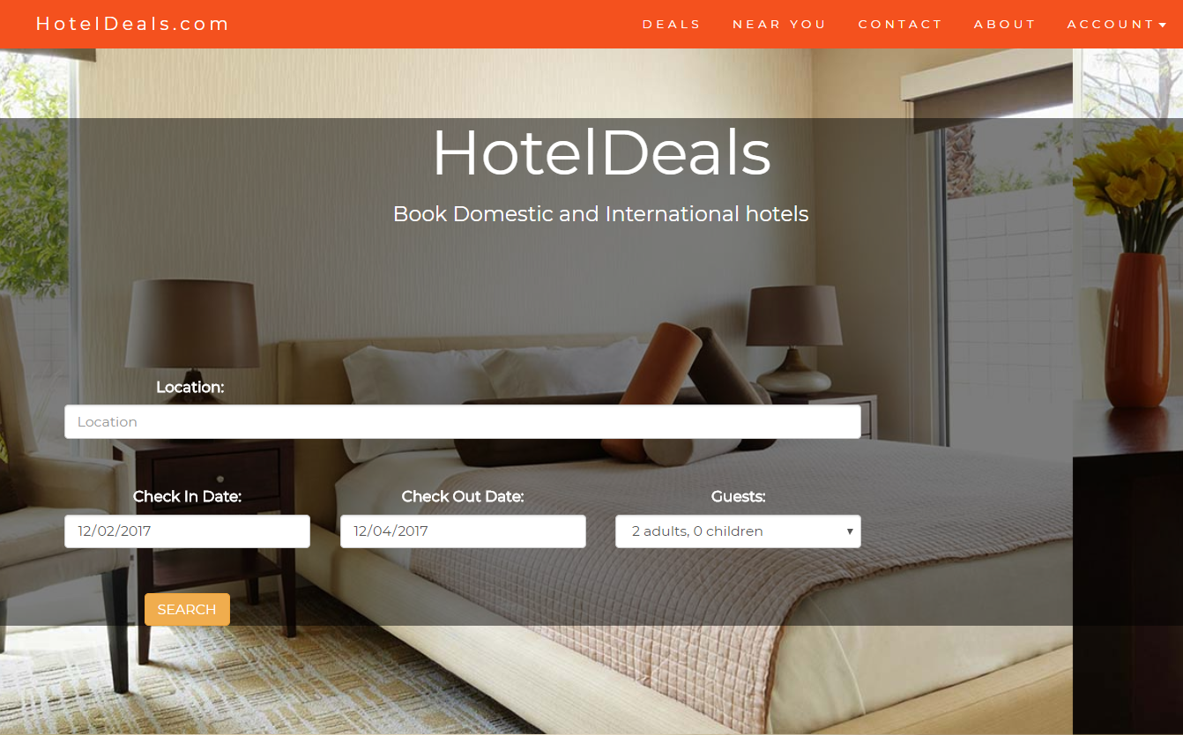

* 1. Autocomplete:

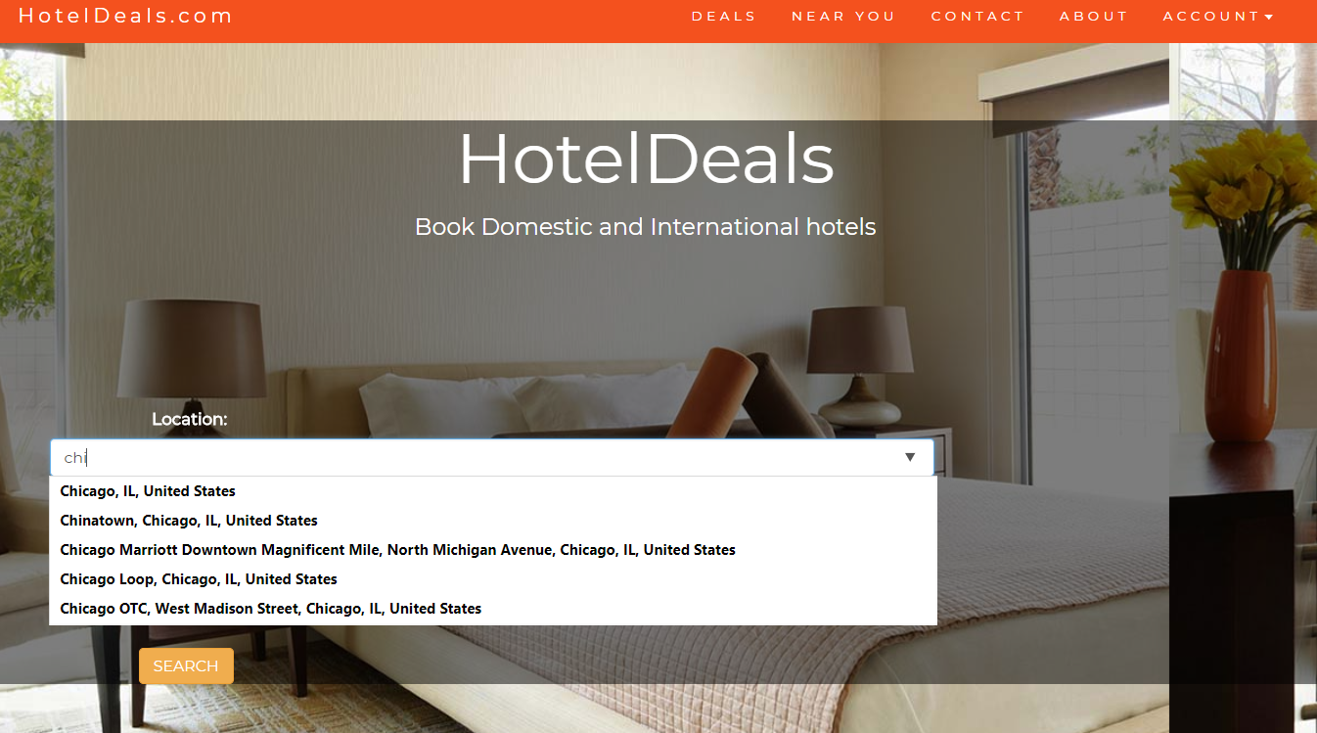

* 1. Login as a Customer:

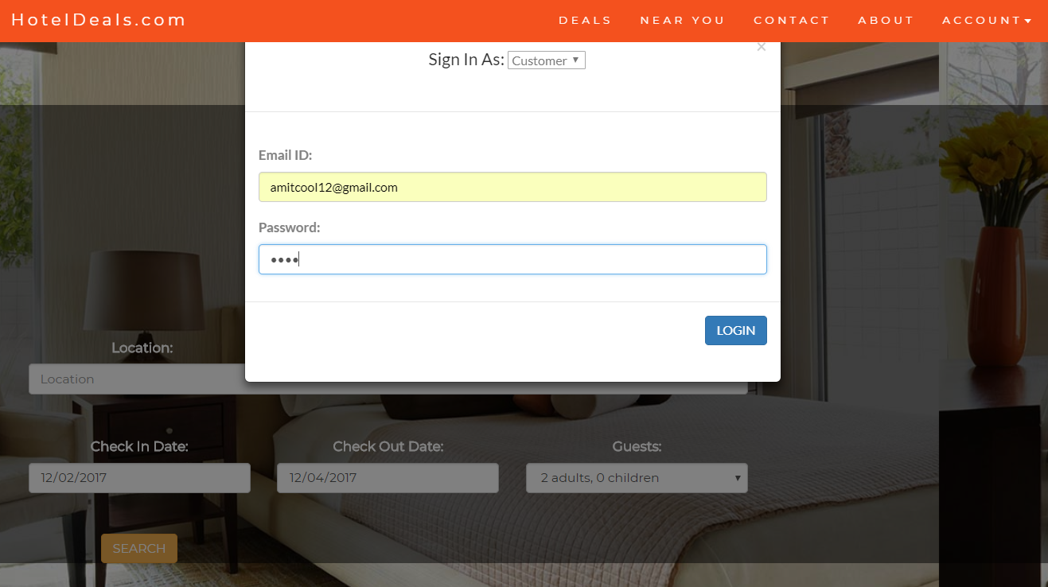

* 1. Sign-up as a Customer:

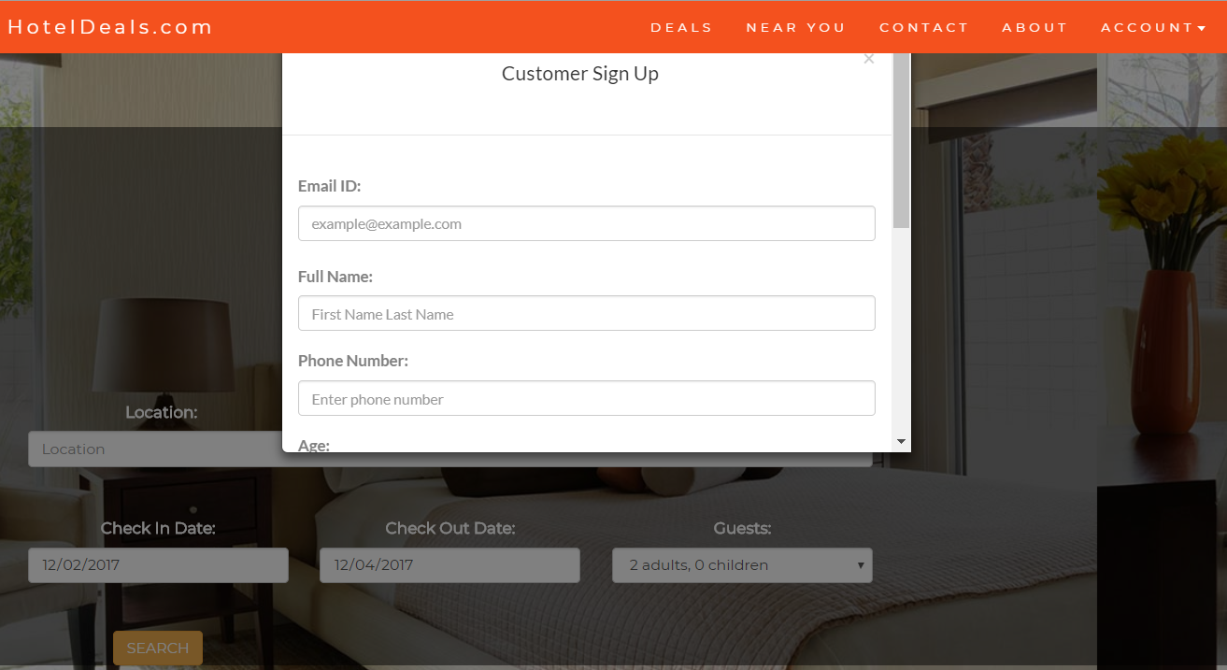

* 1. After registering as a customer, we can see the new customer added in the mongo db.

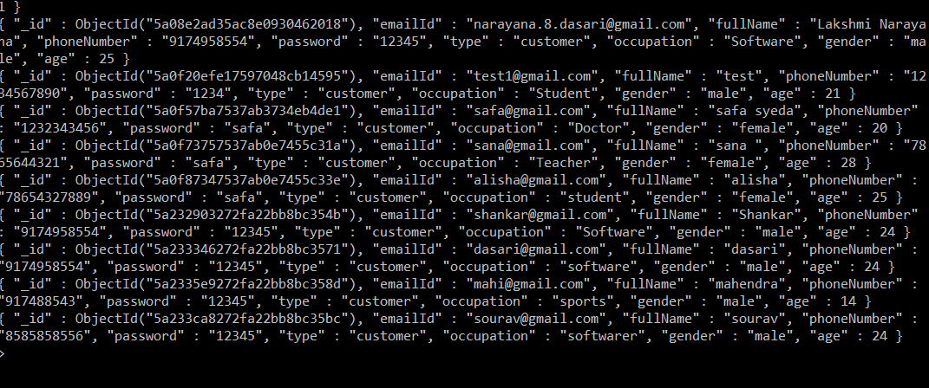

* 1. Login as customer and searching hotels in Chicago.

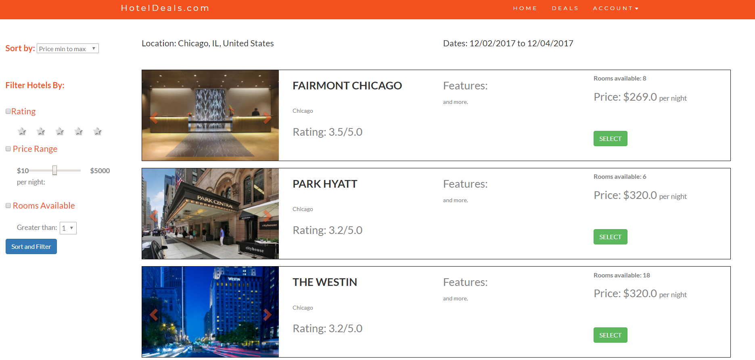

* 1. All the hotels are fetched from MySQL database.

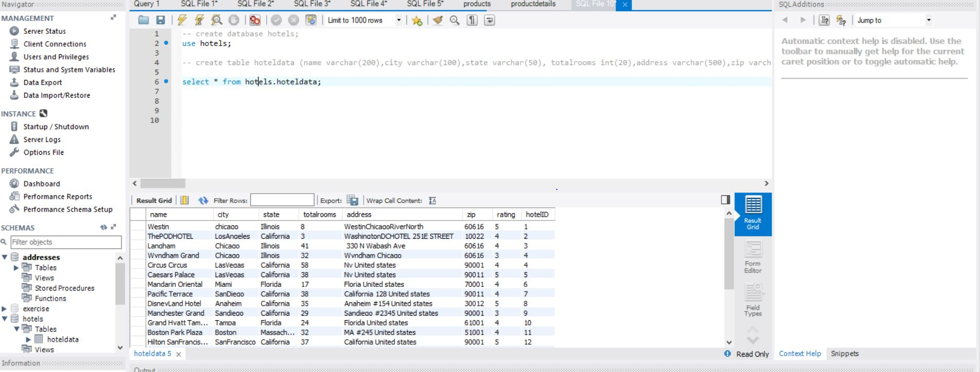

* 1. Now selecting a Particular Hotel we can see the average rating and can also write a Review.

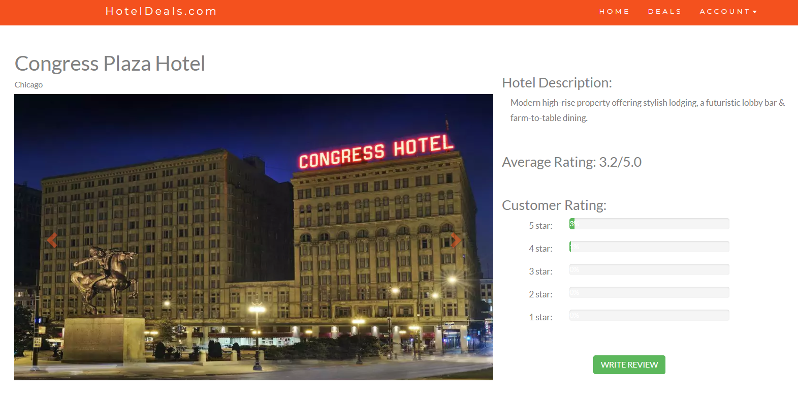

* 1. Scrolling down the page we can find the rooms which are available and the Reviews which are given by the other customers.

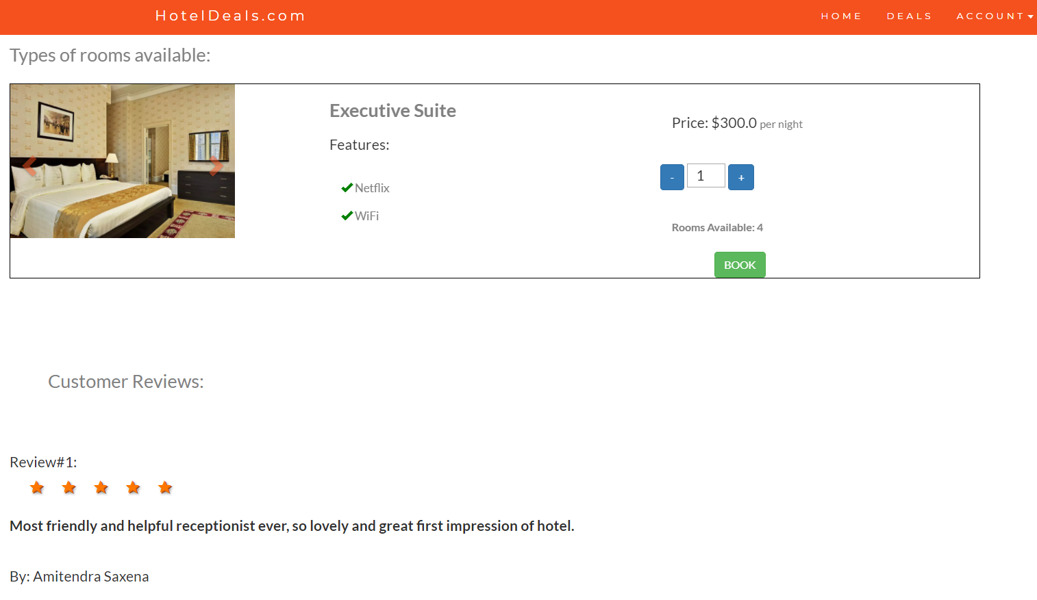

* 1. When we click on book it redirects us to Booking information page.

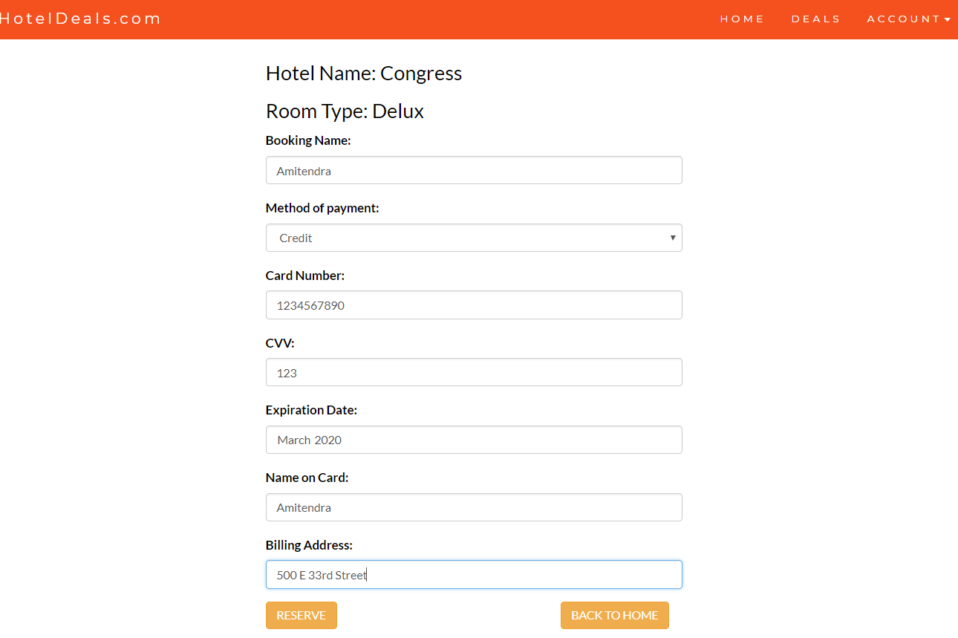

* 1. As we select reserve we can see the hotel room has been booked and can be seen in the mongodb.

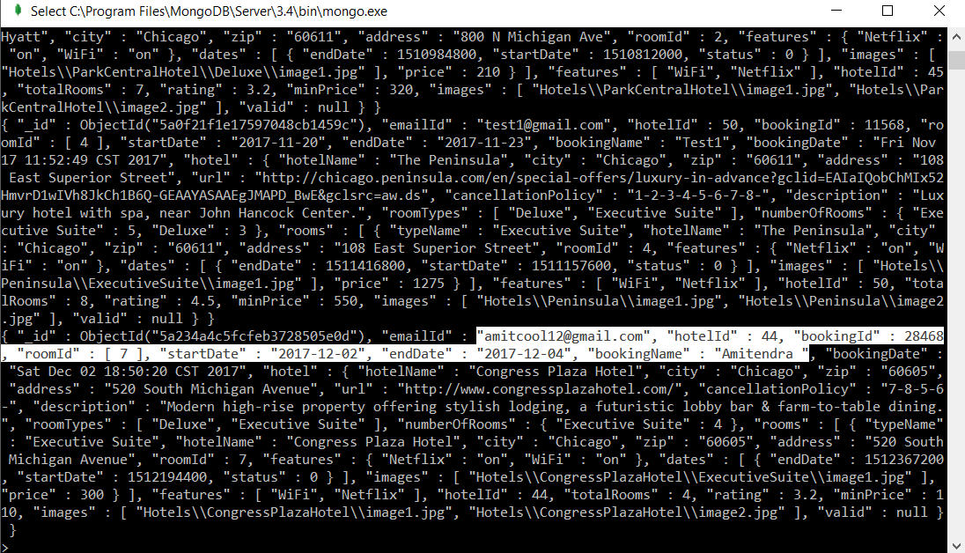

* 1. Now customer can go to their account page and can see their bookings.

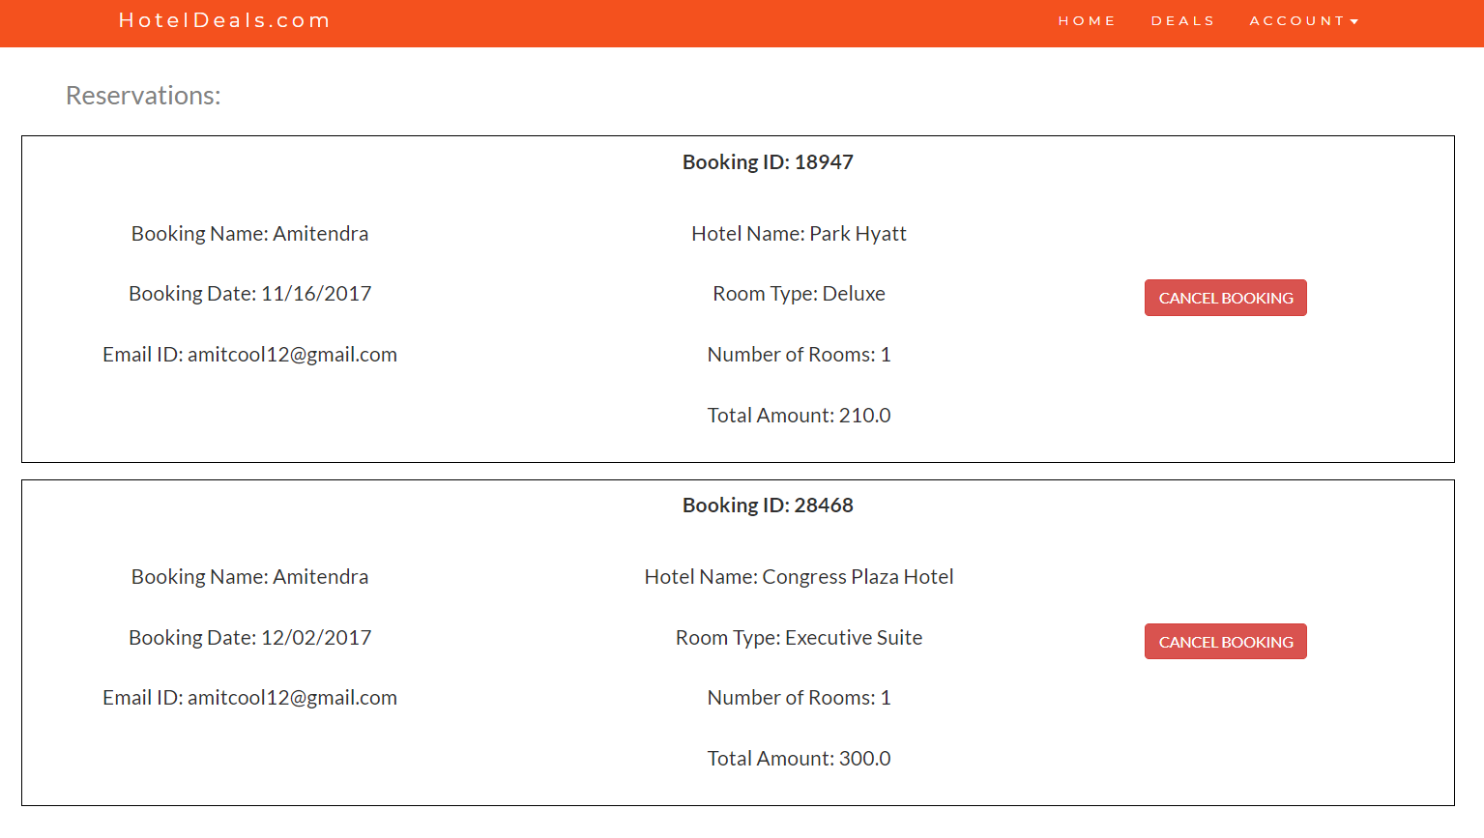

* 1. Users can also see their Profile page from my account options.

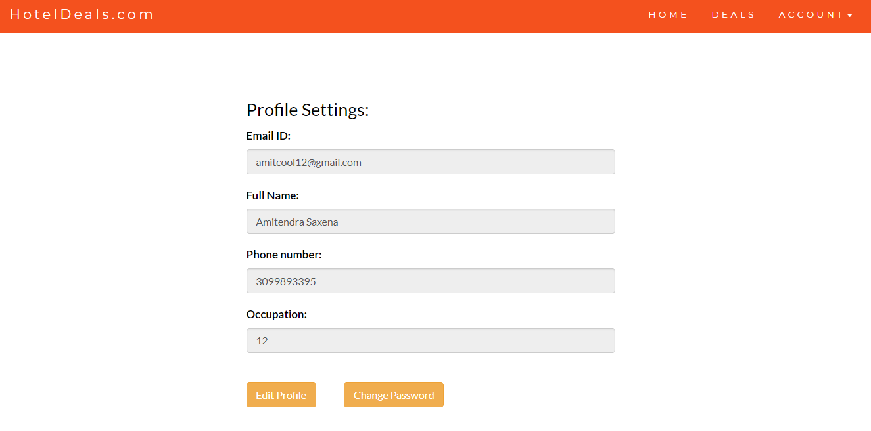

* 1. Users can also write give reviews to Hotels.

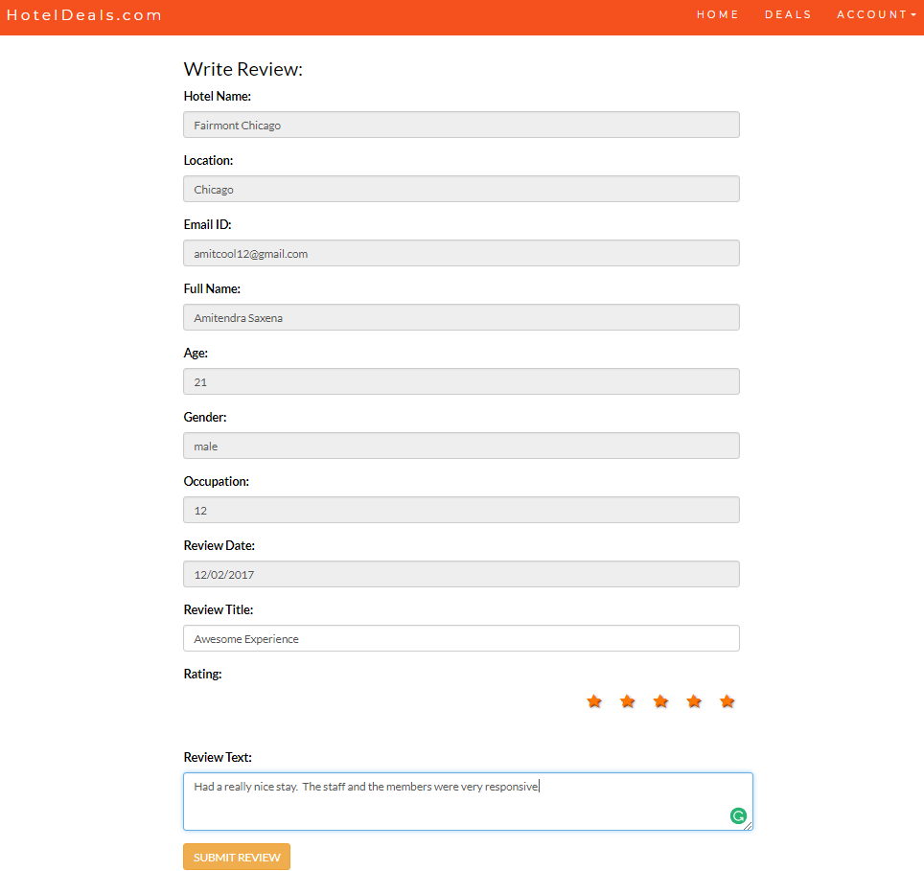

* 1. After submitting reviews we can see the reviews getting stored in mongodb and is also displayed on the specific hotel page.

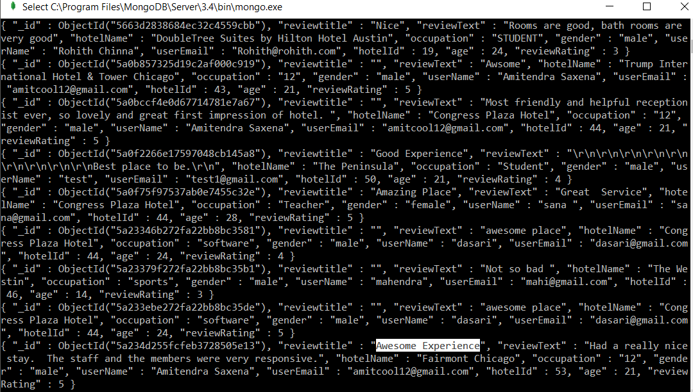

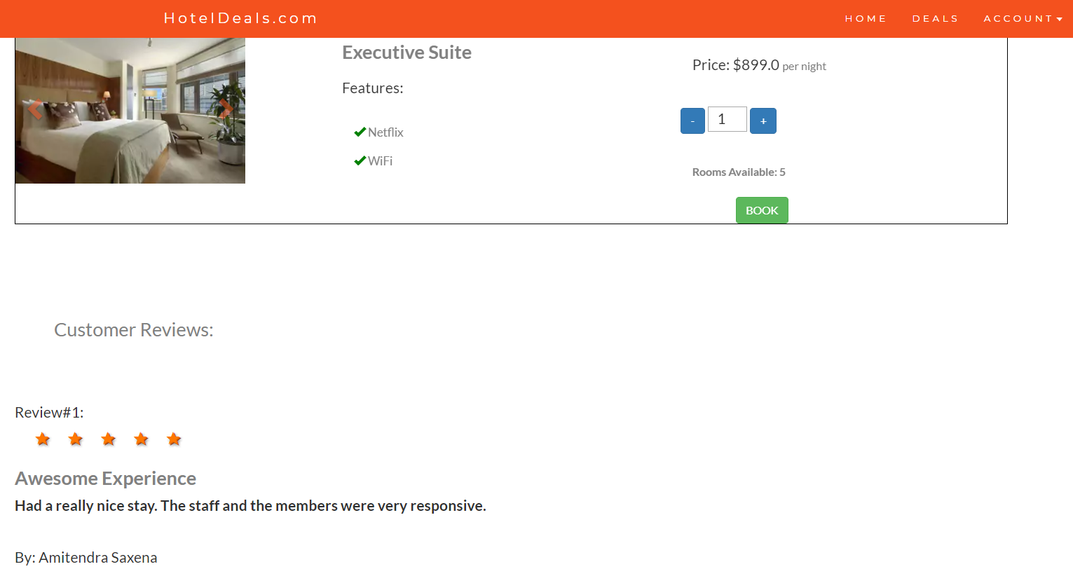

* 1. Now we will sign in as Store Manager.

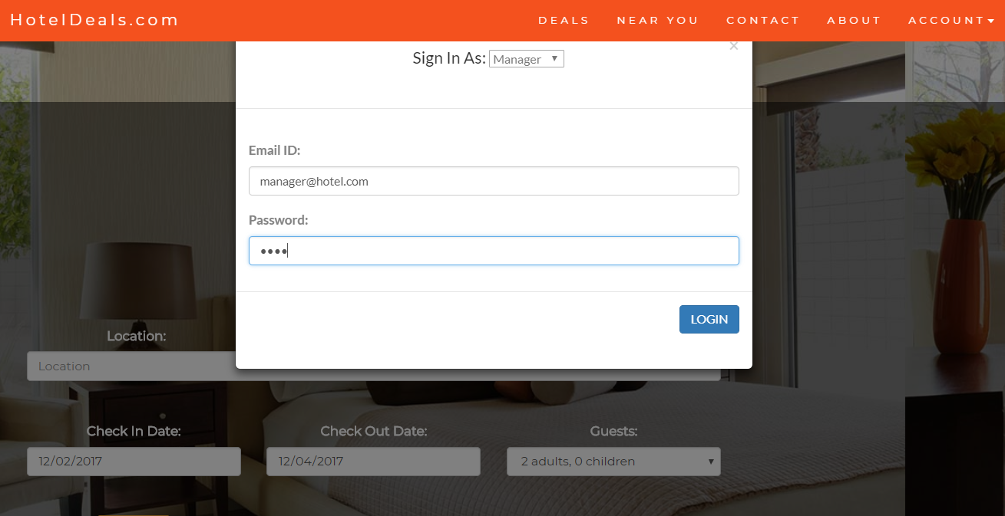

* 1. Hotel Manager can view all the hotel reservations which are done by the customer and can even cancel any reservations.

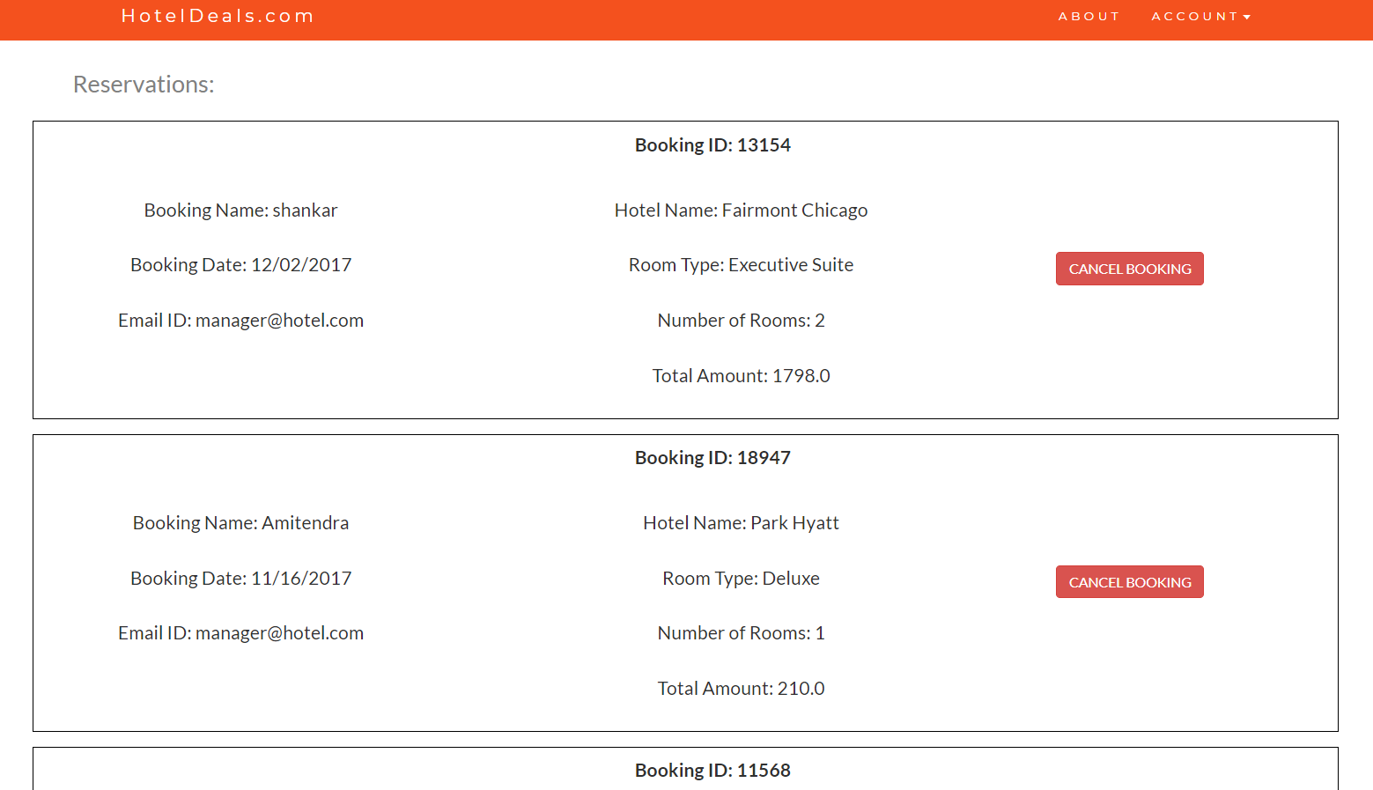

* 1. Now we will login in as an Admin

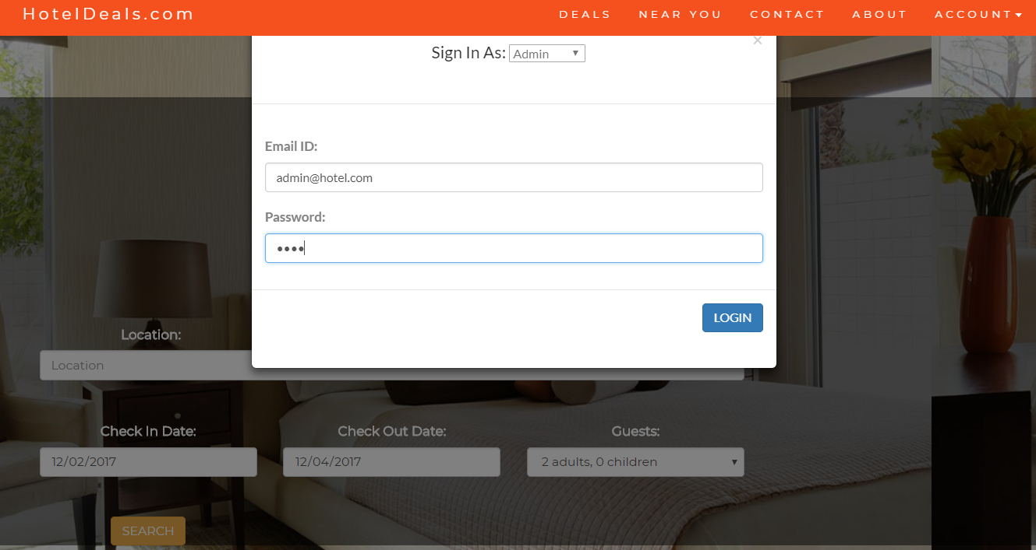

* 1. Admin can see all the hotels which are listed on the website and can perform various operations such as update, remove, add hotels, view bookings and also can see the data analytics.

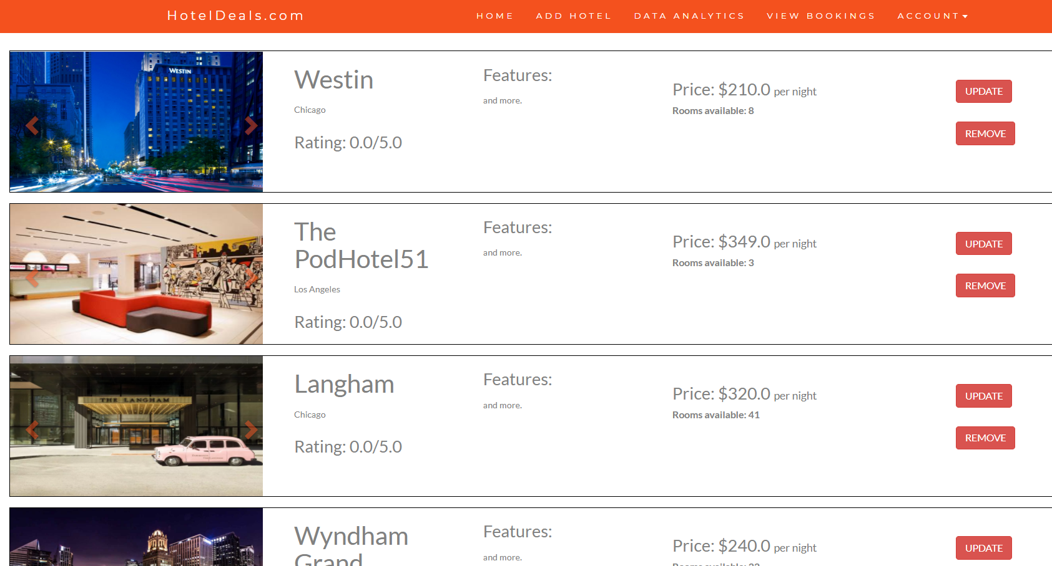

* 1. In Data Analytics the Admin can see Hotels and number of rooms available, Total booking for each room and Top 5 most liked Hotels.

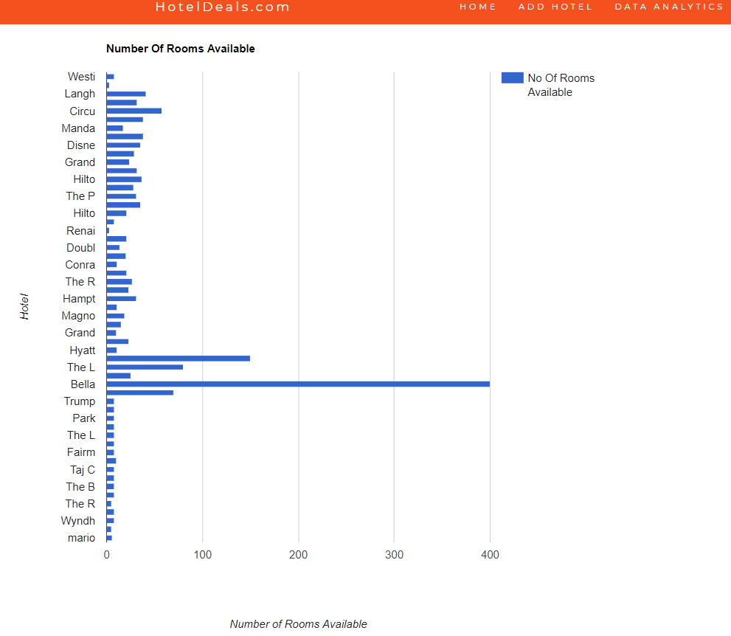

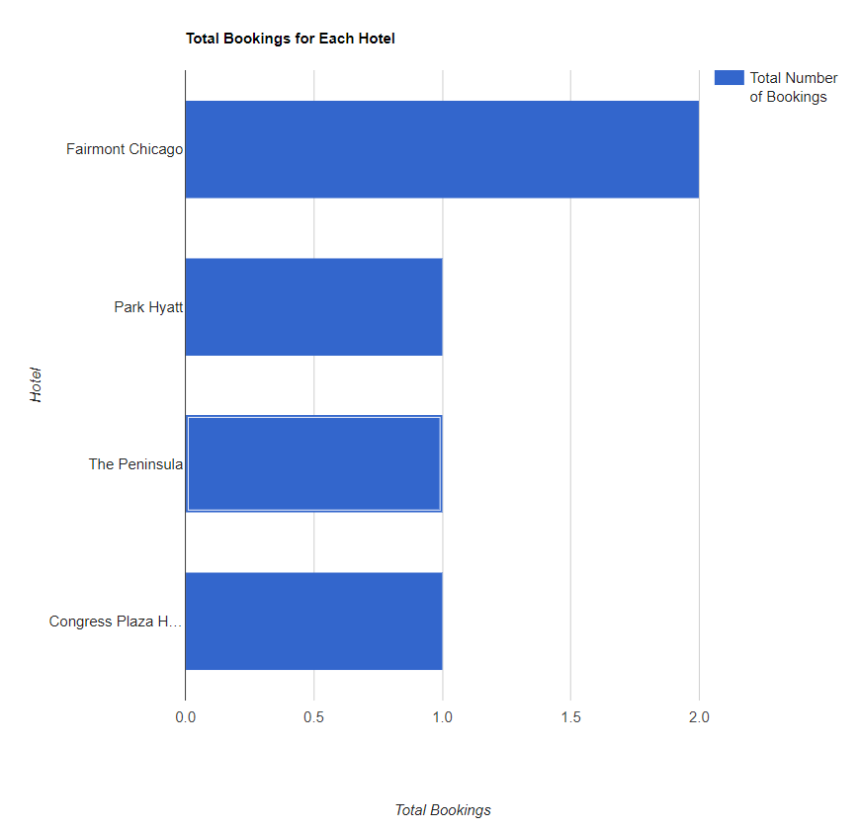

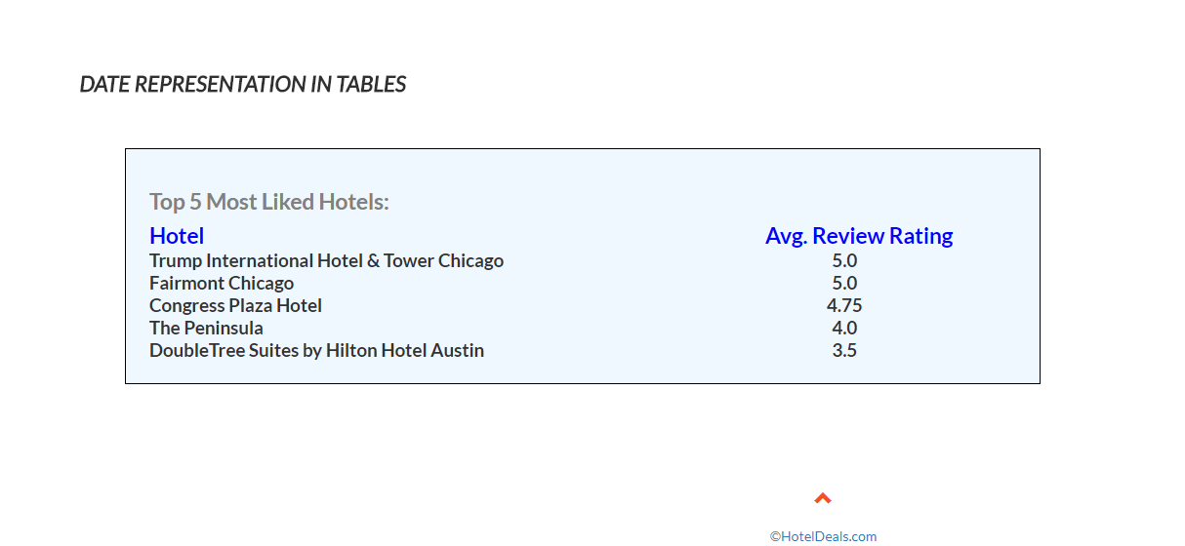

* 1. To add a new hotel admin can add new hotel using add hotel tab.

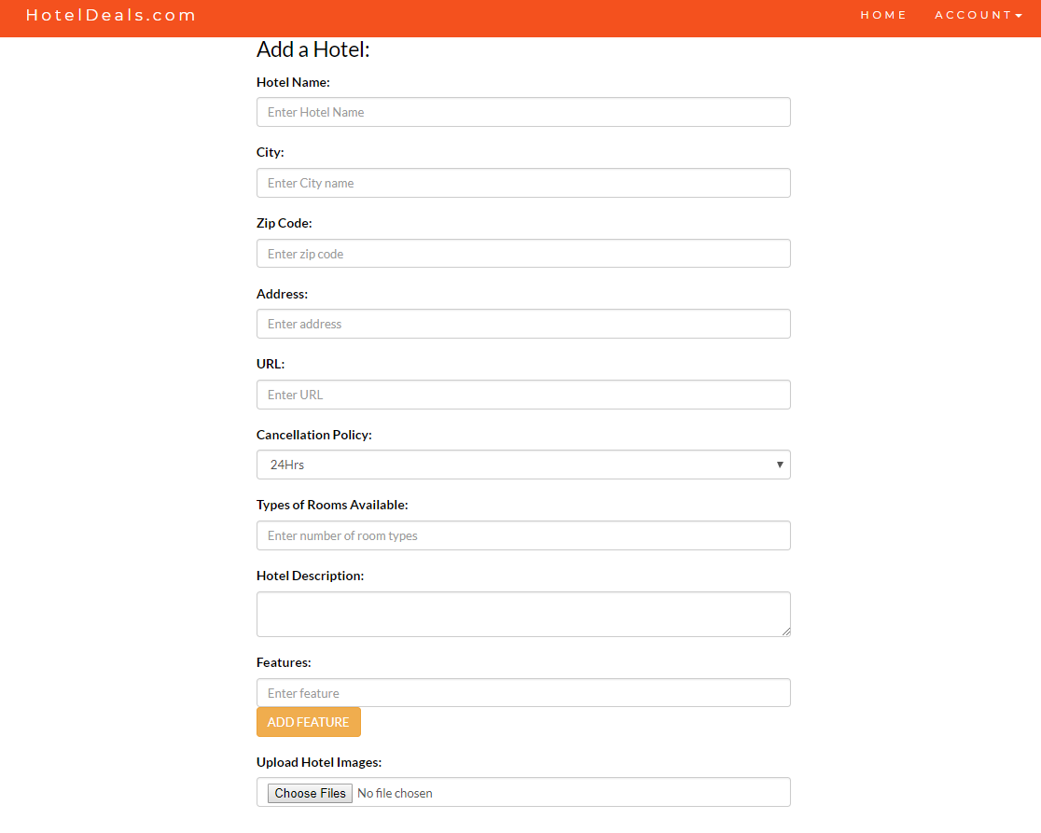

* 1. Admin can also add rooms for each hotels.

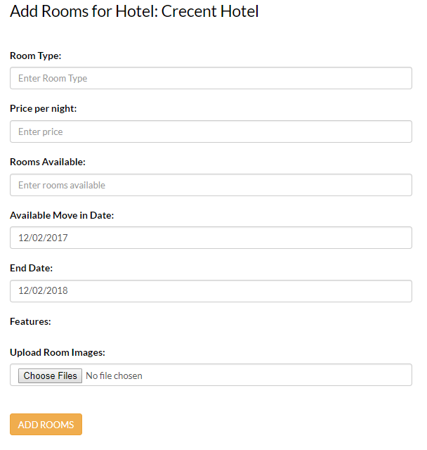

* 1. Admin can view all the reservations which are done by the customers.

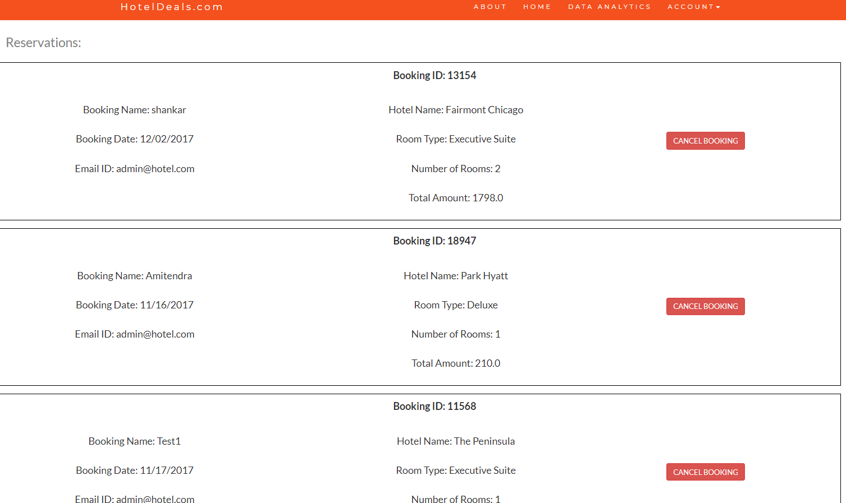

1. **Conclusion:**

This website hoteldeals.com is flexible and dynamic for any user to easily book, cancel and view the reservations. This can be extended for future purposes where we can include more data analysis for the Admin and provide better deals and hotels to the users.